**Day 6**

1.      Categorize products by stock status

(Display product_name, a new column stock_status whose values are based on below condition units_in_stock = 0  is 'Out of Stock' units_in_stock < 20  is 'Low Stock')

 select product_name, case

when units_in_stock = 0 then 'Out of Stock'

when units_in_stock<20 then 'Low Stock'

end as "stock_status"

from products;

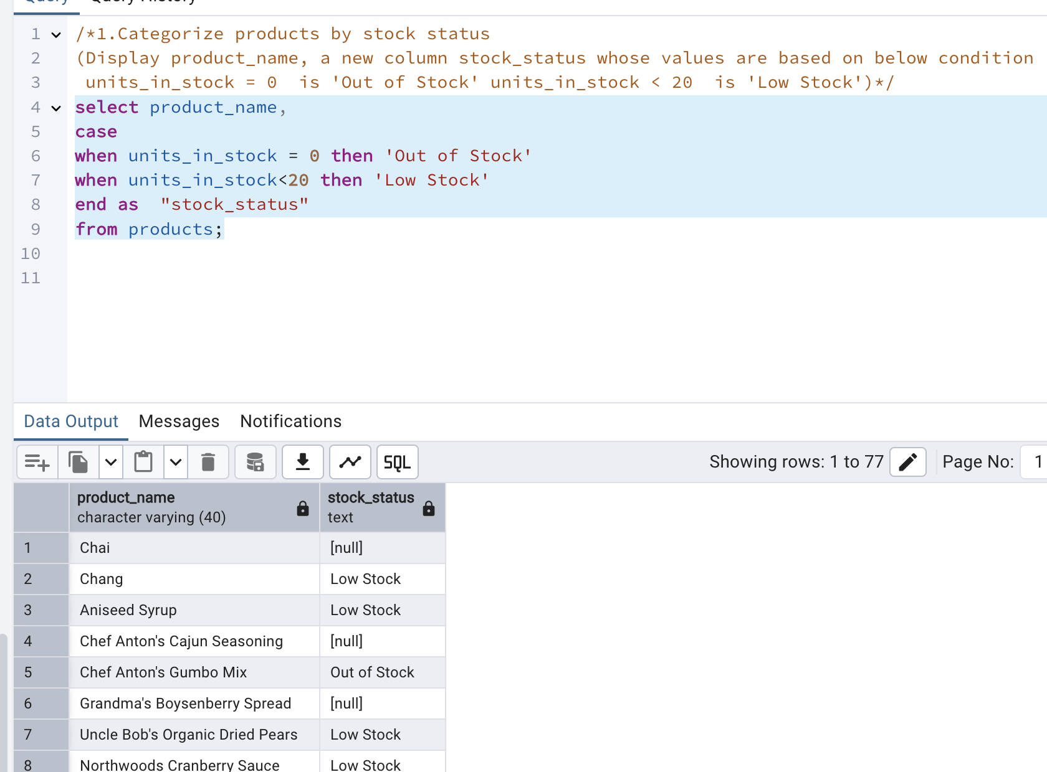

2.      Find All Products in Beverages Category(Subquery, Display product_name,unitprice)

select product_name,unit_price from products where category_id in (select category_id from categories where category_name='Beverages');

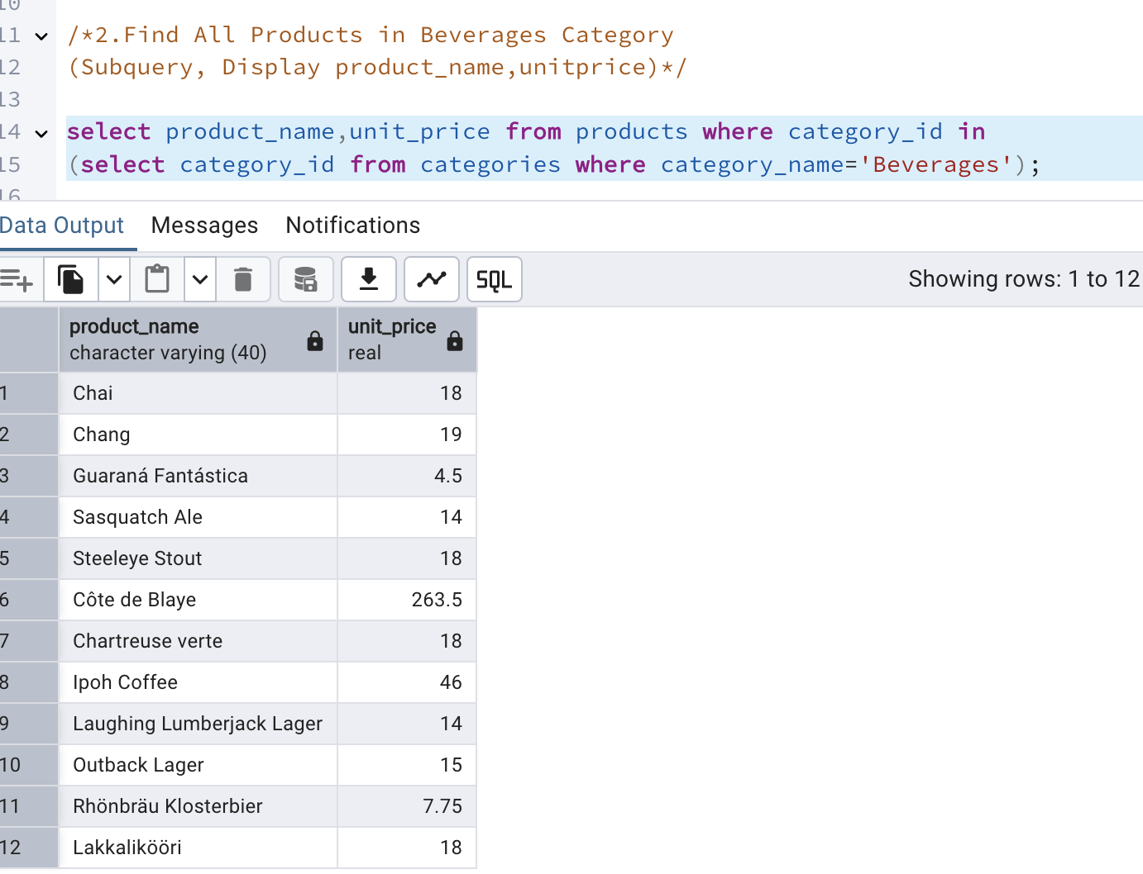

3.      Find Orders by Employee with Most Sales

(Display order_id,   order_date,  freight, employee_id.

Employee with Most Sales=Get the total no.of of orders for each employee then order by DESC and limit 1. Use Subquery)

select order_id,

order_date,

freight,

employee_id from orders where employee_id in (

select employee_id from orders group by employee_id

order by count(*) desc limit 1

) order by 1;

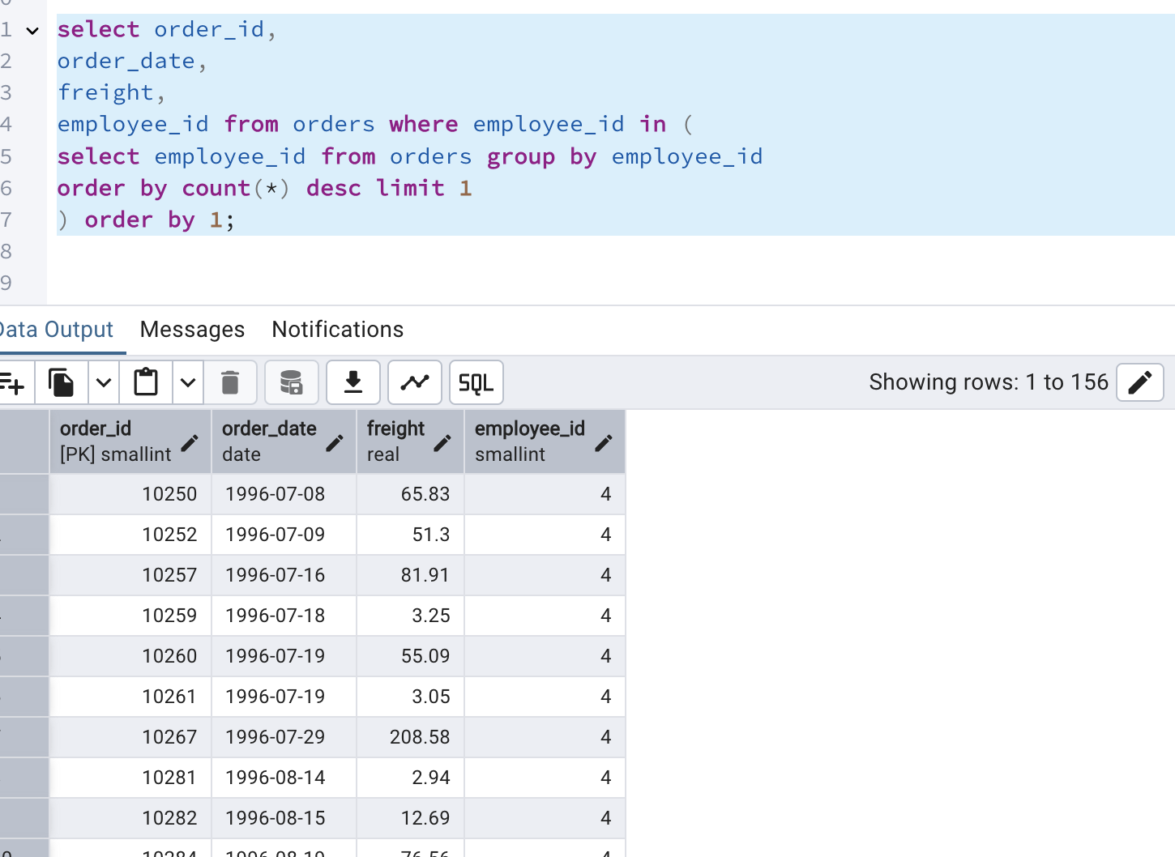

4.      Find orders  where for country!= ‘USA’ with freight costs higher than any order from USA. (Subquery, Try with ANY, ALL operators)

select * from orders where ship_country != 'USA'

and freight > ANY

(select freight from orders where ship_country = 'USA')

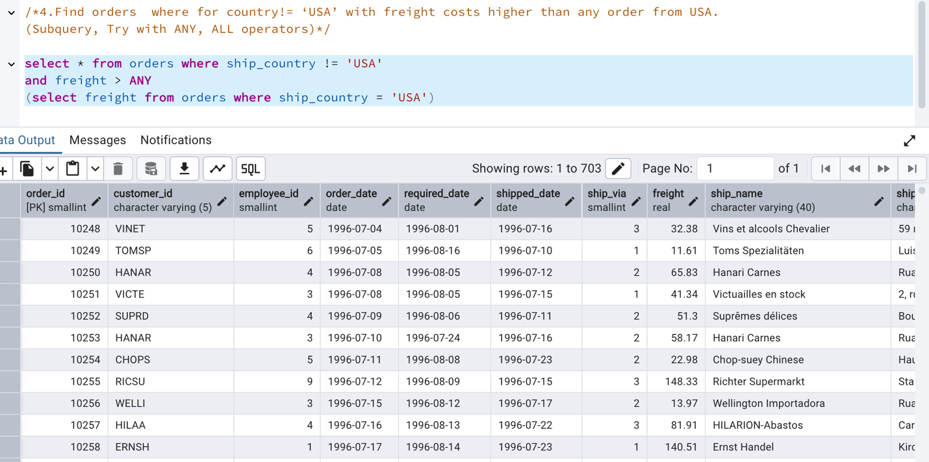

select * from orders where ship_country != 'USA'

and freight > ALL

(select freight from orders where ship_country = 'USA')

